**Cucumber setup:**

Step1:First open file-new- project, Open the Project Wizard

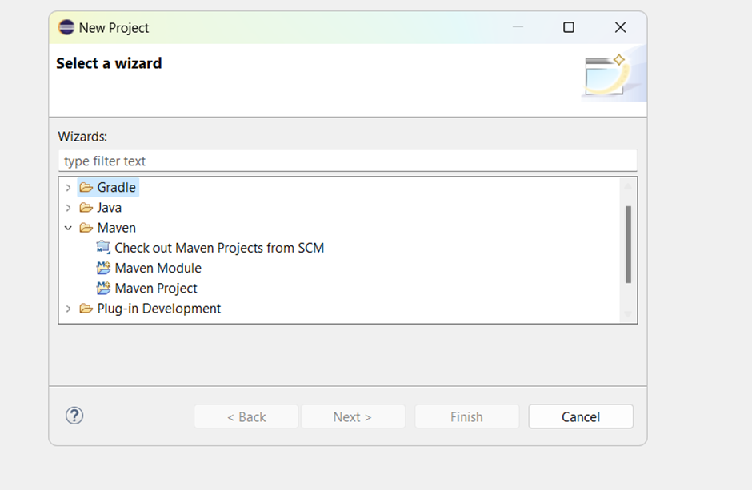

**Step2**:Select maven project click next, select the default work space of eclipse and don’t select the sample workspace checkbox.

**Step3**: You will be on Archtype wizard. In filter add this archetype : maven-archetype-quickstart

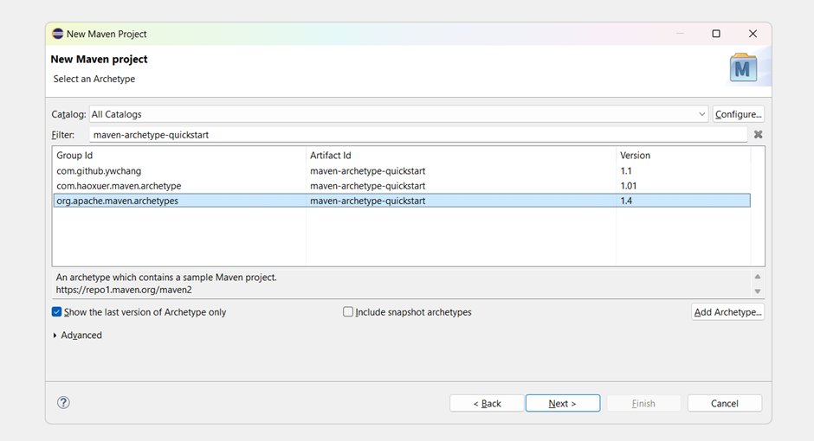

**Step4**:After selecting the 1.4 version click next,then next page open for specify archetype parameters.

**Step5**:Give same name for group id and Artifact id and click on finish.

**Step6**:Now we can see that in console build is started and asks permission type Y and enter and then build will completed.

**Step7**:open project and add all the required dependencies for webdriver,selenium,cucumber,junit and save the pom file.

**Step8**:After we need to install cucumber plugins for that

Go to help-market place-search for cucumber plugins and install

**Step9**: Convert Maven project to Cucumber Project

Right click on the project à go to configure à click on convert to cucumber project

**Step10**:now we can see the C on the project means its sucessfully converted to the cucumber project.